**DAILY ONLINE ACTIVITIES SUMMARY**

|  |  |  |  |  |  |  |  |  |
| --- | --- | --- | --- | --- | --- | --- | --- | --- |
| **Date:** | **15 June** | | | | | **Name:** | **Shanbhag Atish Manoj** | |
| **Sem & Sec** | **6th  Sem ‘B’ Sec** | | | | | **USN:** | **4AL17CS085** | |
| **Online Test Summary** | | | | | | | | |
| **Subject** | | **C programming Quiz and python workshop quiz** | | | | | | |
| **Max. Marks** | | **--** | | **Score** | | | **--** | |
| **Certification Course Summary** | | | | | | | | |
| **Course** | **Workshop exercise solving** | | | | | | | |
| **Certificate Provider** | | | **--** | | **Duration** | | | **--** |
| **Coding Challenges** | | | | | | | | |
| **Problem Statement: 2 programs** | | | | | | | | |
| **Status: Executed** | | | | | | | | |
| **Uploaded the report in Github** | | | | | **yes** | | | |
| **If yes Repository name** | | | | | <https://github.com/atish-shanbhag/Updates> | | | |
| **Uploaded the report in slack** | | | | | **yes** | | | |

**Class and Quiz Snapshots:**

**C programming:**

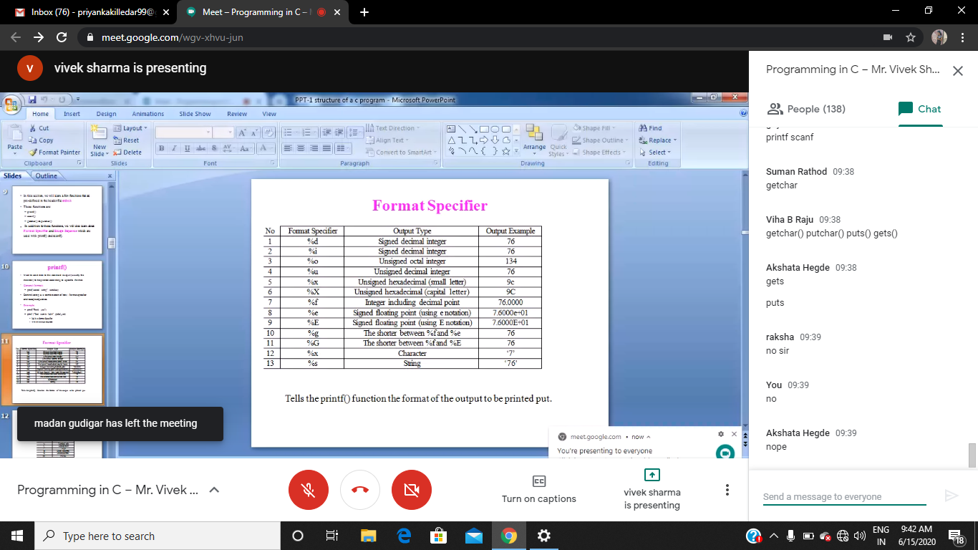

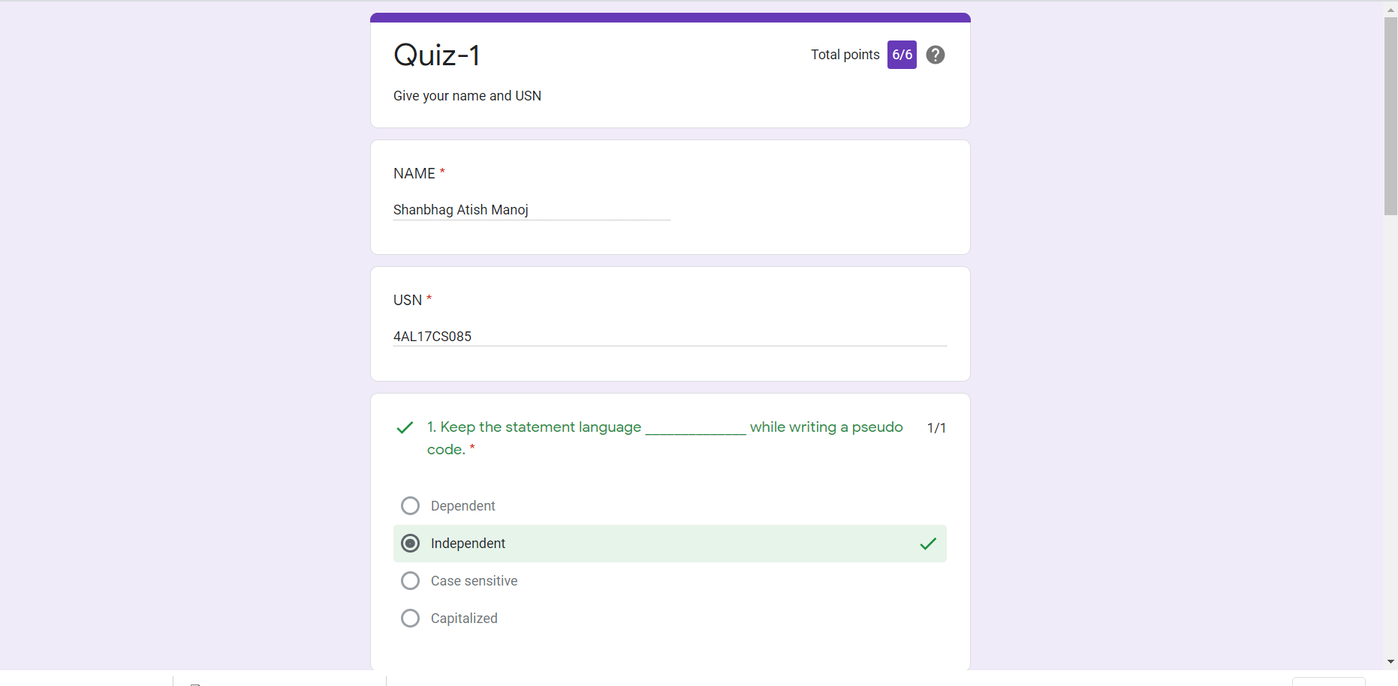

**Python workshop :**

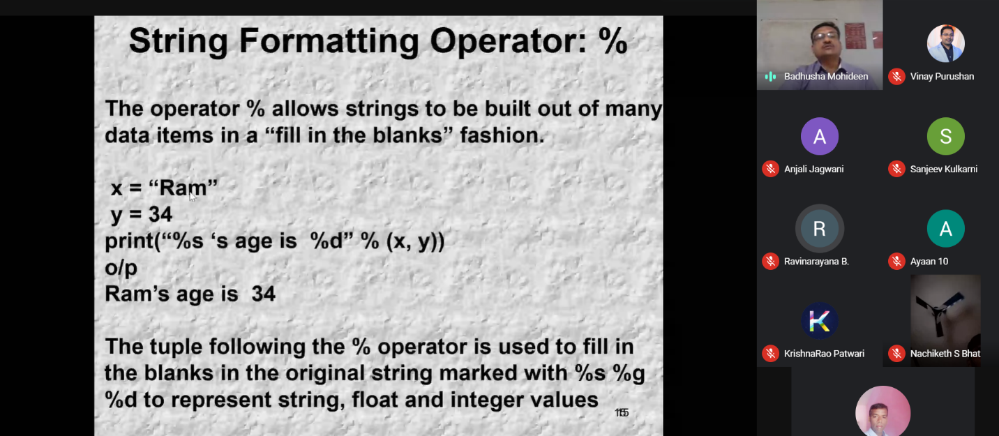

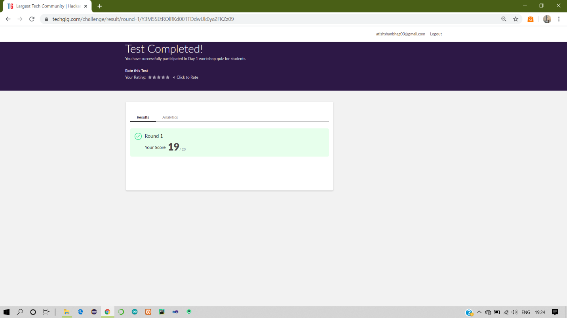

Refer the github link for example programs and exercise programs: <https://github.com/atish-shanbhag/Python_Programming_in_DA_and_ML>

**Coding Challenges Details:**

Refer the github link for detail information :<https://github.com/atish-shanbhag/Updates>

Solved all the problems and the solutions are uploaded in github account.

C programming exercise solved in: <https://github.com/atish-shanbhag/C-Programming_Exercises-Placement>